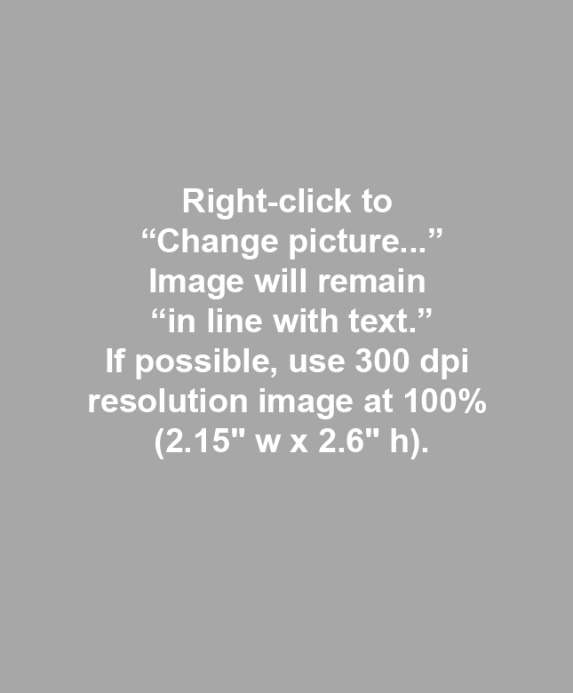
microsoft.com/

TIPS
Page Layout view: Use this setting to see the full page as if printed on paper. (View ribbon, Document tab)
View Gridlines: IMPORTANT! Use this setting to see the table gridlines so that you don’t accidentally click and drag them. (Layout tab, Table group, View Gridlines button)
Non-printing characters: Click the Show/Hide button () located on the Home ribbon, Paragraph group to see extra tabs, returns, etc. that could be messing up your layout. This setting is IMPERATIVE so that the section breaks are visible and NOT disturbed. Please work around the section breaks – don’t delete them.
Styles: Use Styles on the Home ribbon or with the Styles panel (ALT+CTRL+SHFT+S) if any styles need to be applied manually. Do not apply any styling other than those listed.
Delete this box after reading. To select box, click once inside the box and then once directly on the red frame.

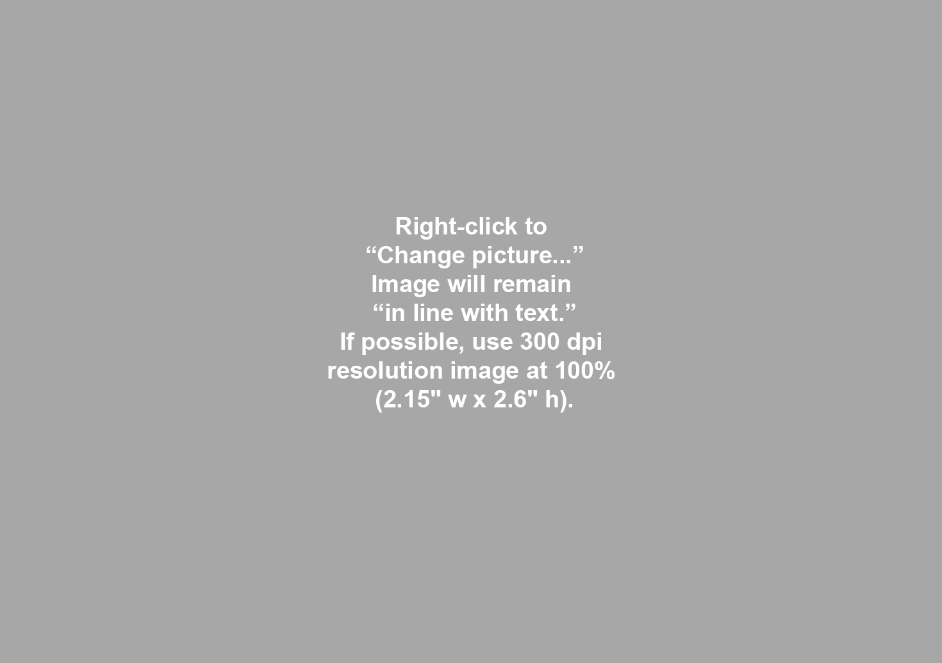 |  | 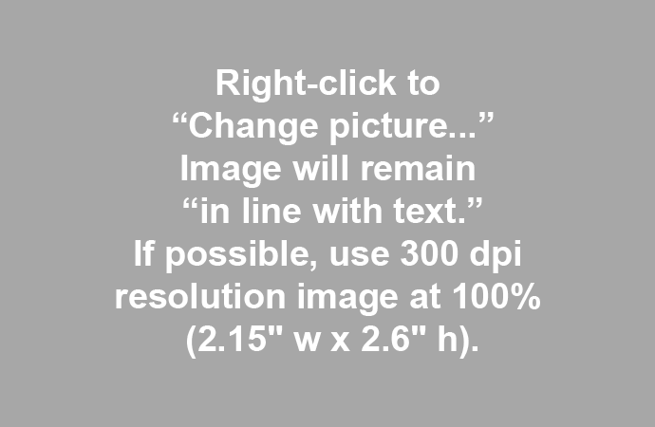
Above:

Left:

